Faculty of Computer Science

Queenstown Branch

ITC511: Application, Testing, & Maintenance(QT)

2018

**PROJECT-Documentation of End Users Help**

Prepared for David Cartman.

Compiled by

Nimantha Randika Suddachchari Nakathige.

Zaine Woolf.

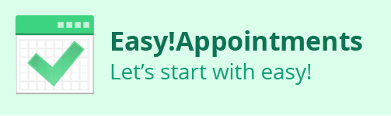

Help

1. How do I setup easy appointment?
2. How to login into back-end?

1. What should I do if I lose my administrator profile password?
2. How to logout from the backend section of Easy! Appointments?
3. How to change details of company such as company’s name, company’s e-mail address and company link?
4. How to change the date format of back end section?
5. How to change the time format of back end section?
6. How to activate the customer notifications option?
7. How to activate the CAPTCHA option?
8. How to setup the working plan for the company?
9. How to book advance timeout for the company?
10. How to add breaks for the company?
11. How to change personnel information of the administrator?
12. How to change the password for administrator?
13. How to add a new customer into back end section?
14. How to check whether your new customer details properly saved on the database?
15. How to add new service on back end section?
16. How to edit customer details on back-end?
17. How to edit services details on back-end?
18. How to delete services details on back-end?
19. How to delete customers details on back-end?
20. How to add providers for each service on back end section?
21. How to edit service provider details on back-end?
22. How to delete service provider details on back end?

# How to setup easy appointment?

Answer: -

1. Please follow the weblink to gain access into Easy! Appointments installation page.

<http://3.83.212.41/appointments-1/index.php/backend>

1. Then you will able to gain access to following Welcome page.

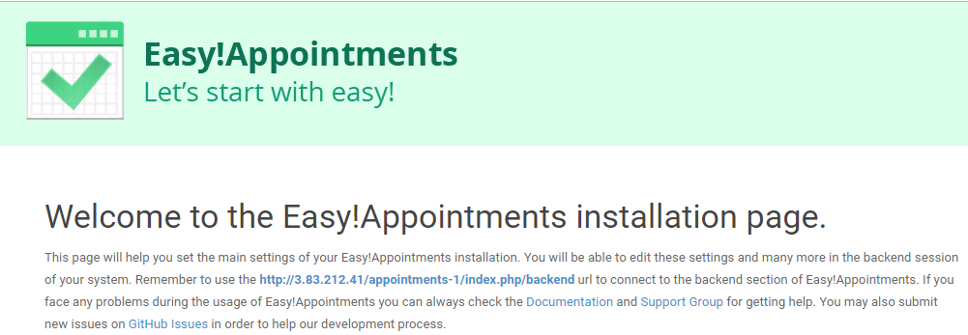

1. Now, administrator needs to fill the following fields using Company details as follows;

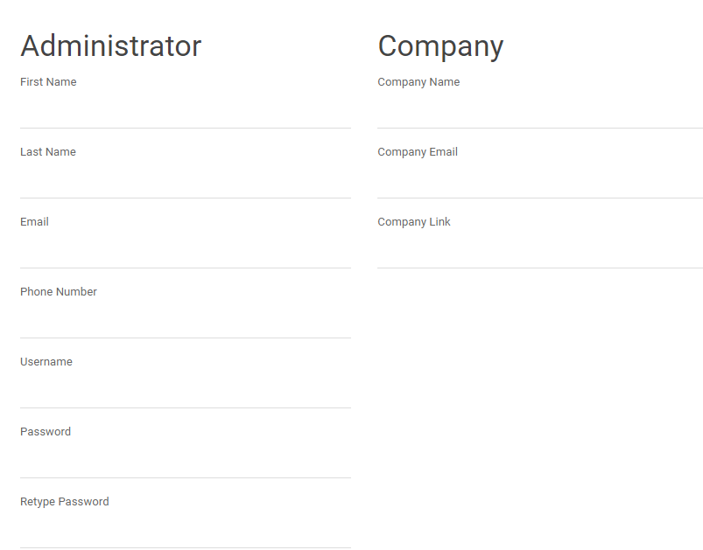

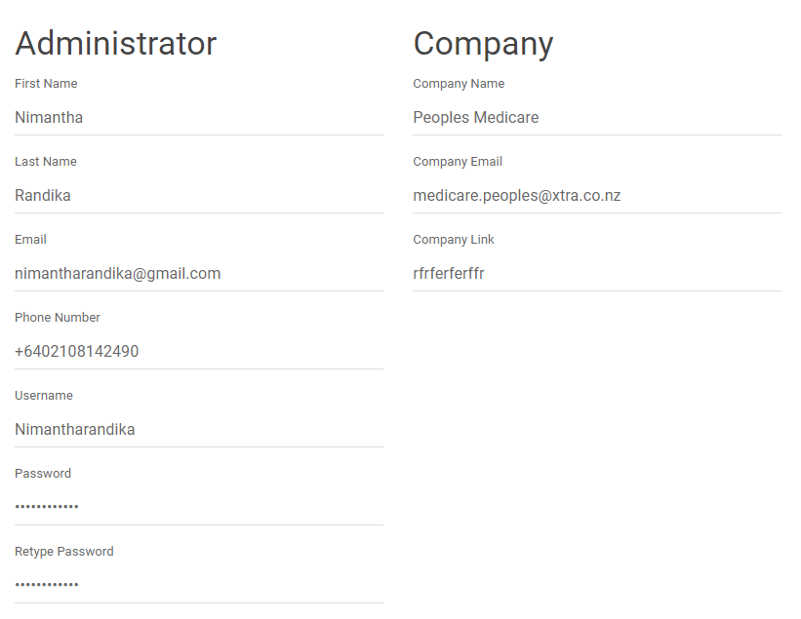

1. After completing above form, simply double click on Install Easy! Appointments.

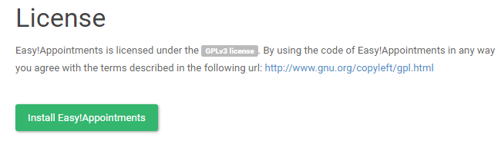

# How to log in/gain access to the Back-end section of Easy! Appointments?

Answer: -

Please follow the steps below carefully to log in to the Back-end section of Easy! Appointments.

1. Please follow the below URL address;

<http://54.165.120.191/appointments-1/>

1. Double click the login link bottom of the first booking page of Easy! Appointments as follows;

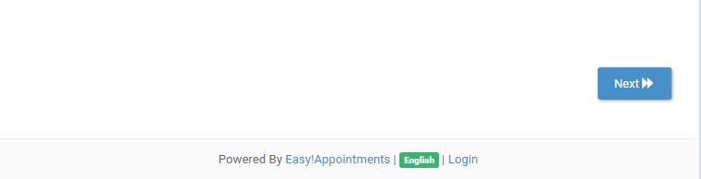

1. After that, you will able to gain access to following form

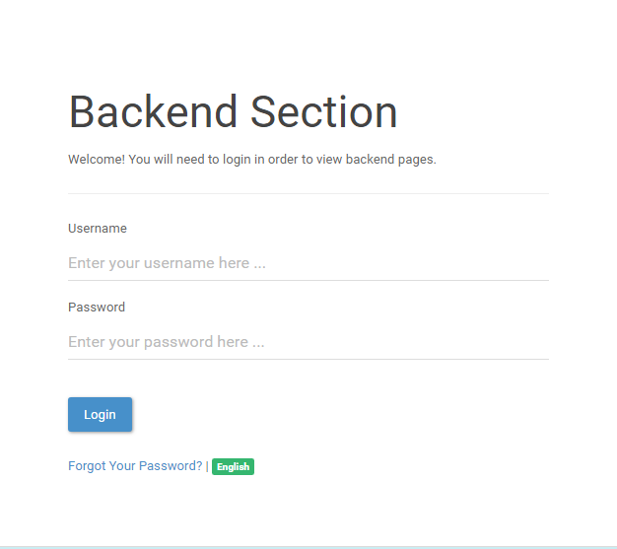

1. Then, please enter Username and Password and hit  or press Enter button as follows;

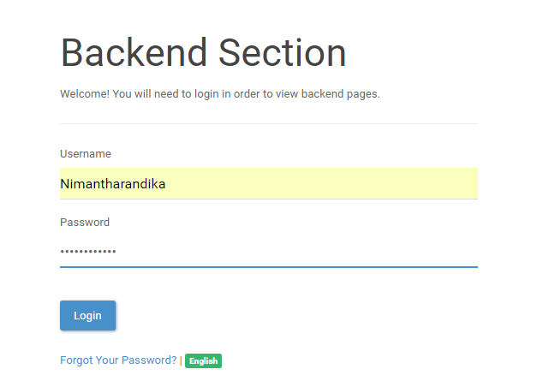

1. Then you will able to gain access to the back-end section successfully as follows;

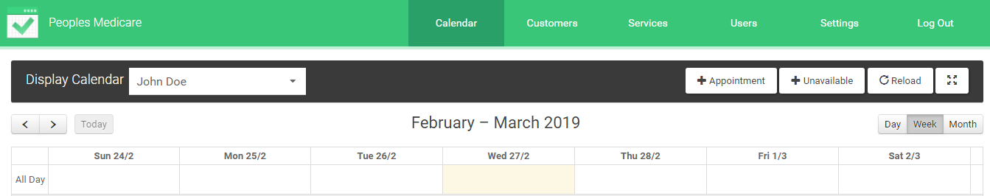

Troubleshooting

If you receive error message down below, please double check the details you entered in the boxes.

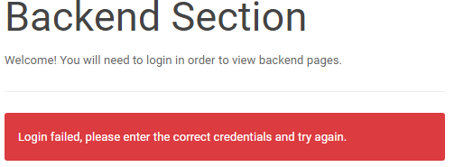

What should I do if I lose my administrator profile password?

Answer: -

In Easy! Appointments back-end section, there is a special facility to regenerate a new administrator user password. But in order to do so, at least you need to have administrator profile name & email address.

Please follow below steps carefully to regenerate your new password.

1. Please select the Forgot Your Password link as below in the Welcome to back-end section page.

Special note: Please refer to question number 2 in General section to learn how to gain access to welcome page of Back-end section.

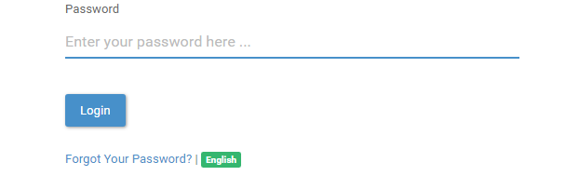

1. Then, you will redirect into following interface;

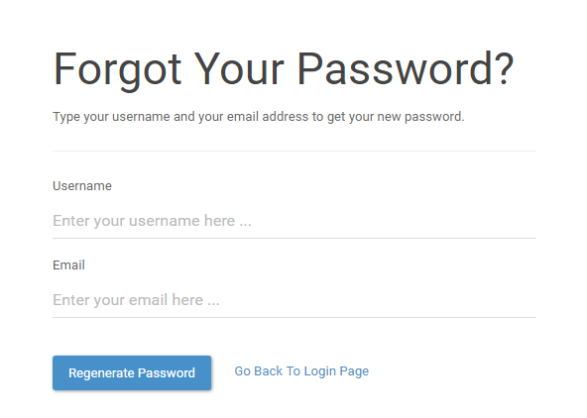

1. Then, please fill the form using your Username and email address as follows;

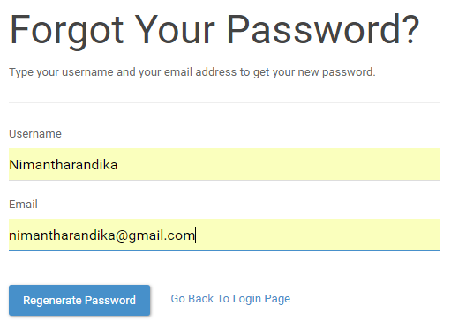

1. Then click on  button to proceed further.
2. Then, system will send you a verification email to the assigned email address.
3. Please double click the verification link in your inbox.

# How to logout from the backend section of Easy! Appointments?

Answer: -

Please follow below steps carefully to logout from the backend section of Easy! Appointments.

1. Please navigate the top menu bar section of Back-End homepage.



1. Then, click on log out button at right corner.



1. Then you will able to enter following interface. And, it means you successfully log out from the Back-End section.

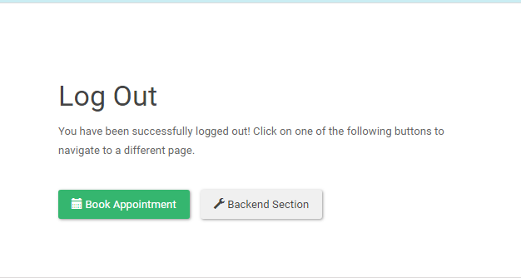

# How to change details of company such as company’s name, company’s e-mail address and company link?

Answer: -

Please follow below steps carefully to change details of company such as company’s name, company’s e-mail address and company link.

1. Select the Settings button on top navigation menu bar at Back-End Homepage.



1. Then you will able to enter General settings section of Back-end.

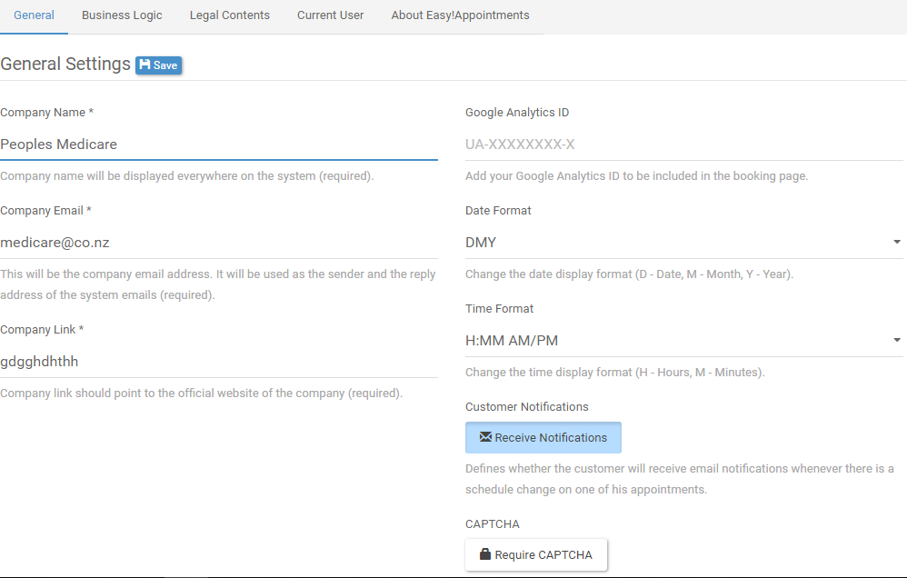

1. Please update the following fields in order to change Company’s name, Company’s email address and company link

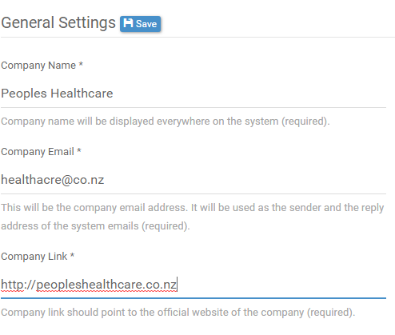

1. And then, click  button on top to save your update.

# How to change the date format of back end section?

Answer: -

Please follow below steps carefully to change date format.

1. Select the Settings button on top navigation menu bar at Back-End Homepage.



1. Then you will able to enter General settings section of Back-end.



1. In the General settings section, please follow the below option to change the date format.

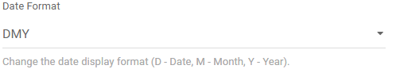

1. Use the scroll bar option to change the date formats as you prefer;

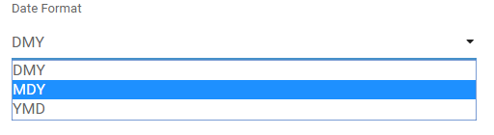

1. And then, click  button on top to save your update.

# How to change the time format of back end section?

Answer: -

Please follow below steps carefully to change time format.

1. Select the Settings button on top navigation menu bar at Back-End Homepage.



1. Then you will able to enter General settings section of Back-end.



1. In the General settings section, please find the below option to change the time format.

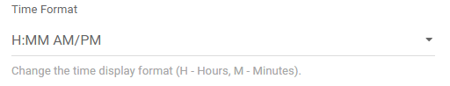

1. Use the scroll bar option to change the Time Format.

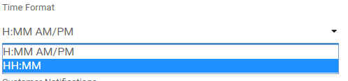

1. And then, click  button on top to save your update.

# How to activate the customer notifications option?

Answer: -

Defines whether the customer will receive email notifications whenever there is a schedule change on one of his appointments.

Please follow below steps carefully to activate customer notifications option.

1. Select the Settings button on top navigation menu bar at Back-End Homepage.



1. Then you will able to enter General settings section of Back-end.



1. In the General settings section, please find the below to activate customers notifications option and double click on Receive Notifications.

And it will turn it to blue color.

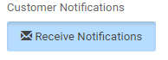

1. And then, click  button on top to save your update.

# How to activate the CAPTCHA option?

Answer: -

When enabled, the customers will have to type a random generated CAPTCHA string before booking/updating an appointment.

Please follow below steps carefully to activate CAPTCHA option.

1. Select the Settings button on top navigation menu bar at Back-End Homepage.



1. Then you will able to enter General settings section of Back-end.



1. In the General settings section, please find the below to activate CAPTCHA option and double click on CAPTCHA.

And it will turn it to blue color.

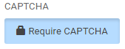

1. And then, click  button on top to save your update.

# How to setup the working plan for the company?

Answer: -

Mark below the days and hours that your company will accept appointments. You will be able to adjust appointments in non-working hours, but the customers will not be able to book appointments by themselves in non-working periods. This working plan will be the default for every new provider record, but you will be able to change each provider's plan separately by editing his record.

Please follow below steps carefully to setup the working plan for the company.

1. Select the Settings button on top navigation menu bar at Back-End Homepage.



1. Then you will able to enter General settings section of Back-end.



1. On the top navigation bar select, Business logic button.



1. Then you will able to, enter following interface.

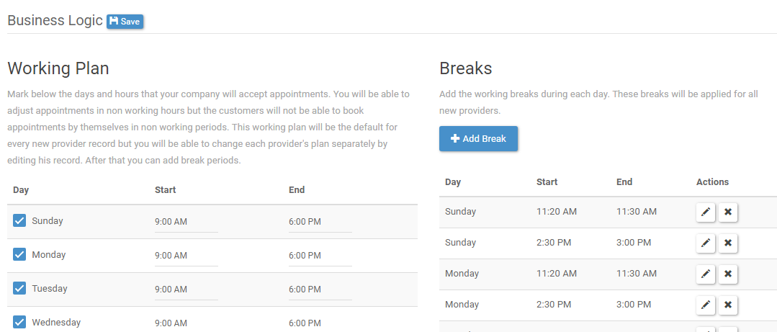

1. On the Working plan section, you have privilege to select the dates and time periods for each date.
2. Simply check the date boxes you want to add.

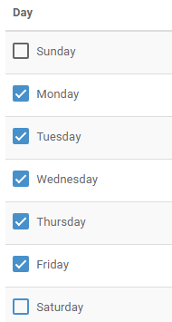

1. To setup the time, just select the time field and use the time tool to adjust the time period.

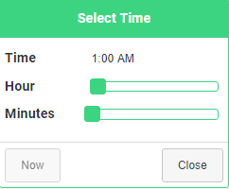

1. And then, click  button on top to save your update.

# How to book advance timeout for the company?

Answer: -

Define the timeout (in minutes) before the customers can book or re-arrange appointments with the company.

Please follow below steps carefully to book advance timeout for the company.

1. Select the Settings button on top navigation menu bar at Back-End Homepage.



1. Then you will able to enter General settings section of Back-end.



1. On the top navigation bar select, Business logic button.



1. Then you will able to, enter following interface.



1. Just below to the Working plan section, you could find out advance timeout section.

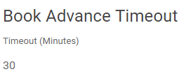

1. Use the scroll down buttons to adjust the timeout you prefer.
2. And then, click  button on top to save your update.

# How to add breaks for the company?

Answer: -

Add the working breaks during each day. These breaks will be applied for all new providers.

Please follow below steps carefully to add breaks for company.

1. Select the Settings button on top navigation menu bar at Back-End Homepage.



1. Then you will able to enter General settings section of Back-end.



1. On the top navigation bar select, Business logic button.



1. Then you will able to, enter following interface.



1. Right next to the Working plan section, you could find out break time section.

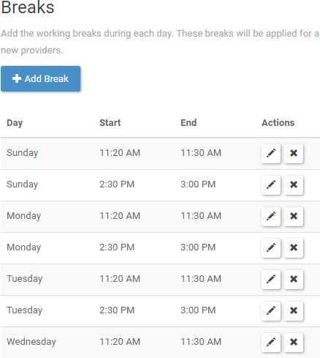

1. Select the  button to add break times.
2. And then, click  button on top to save your update.

# How to change personnel information of the administrator?

Answer: -

Please follow below steps carefully to change the personnel information of the administrator.

1. Select the Settings button on top navigation menu bar at Back-End Homepage.



1. Then you will able to enter General settings section of Back-end.



1. On the top navigation bar select, Business logic button.



1. Then you will be able to enter Current user section,

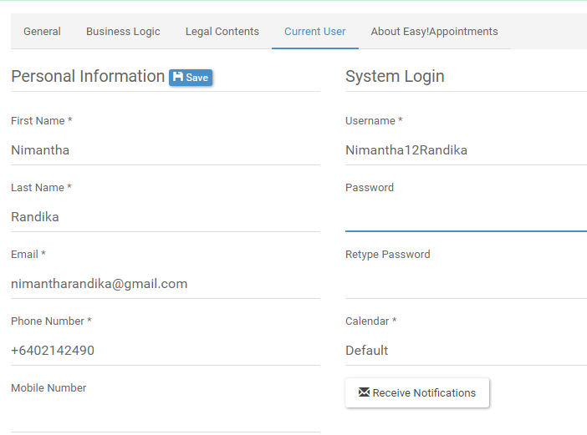

1. Please update administrator’s personal detail on following section.

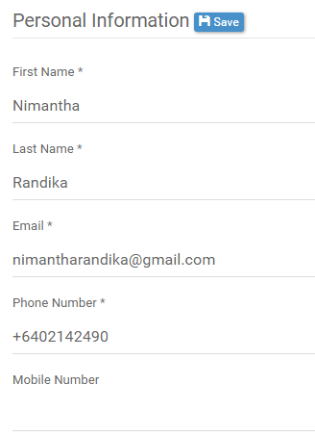

1. And then, click  button on top to save your update.

# How to change the password for administrator?

Answer: -

Please follow below steps carefully to change the personnel information of the administrator.

1. Select the Settings button on top navigation menu bar at Back-End Homepage.



1. Then you will able to enter General settings section of Back-end.



1. On the top navigation bar select, Business logic button.



1. Then you will be able to enter Current user section,



1. Please refer to the System login sub section and change the password as follows;

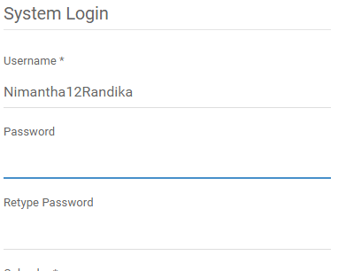

1. And then, click  button on top to save your update.

# How to add a new customer into back end section?

Answer: -

Please follow the below steps to add anew customer and save it in the database.

1. Please select the customers section on top navigation bar menu on back-end homepage.



1. Then you will be able to enter following interface;

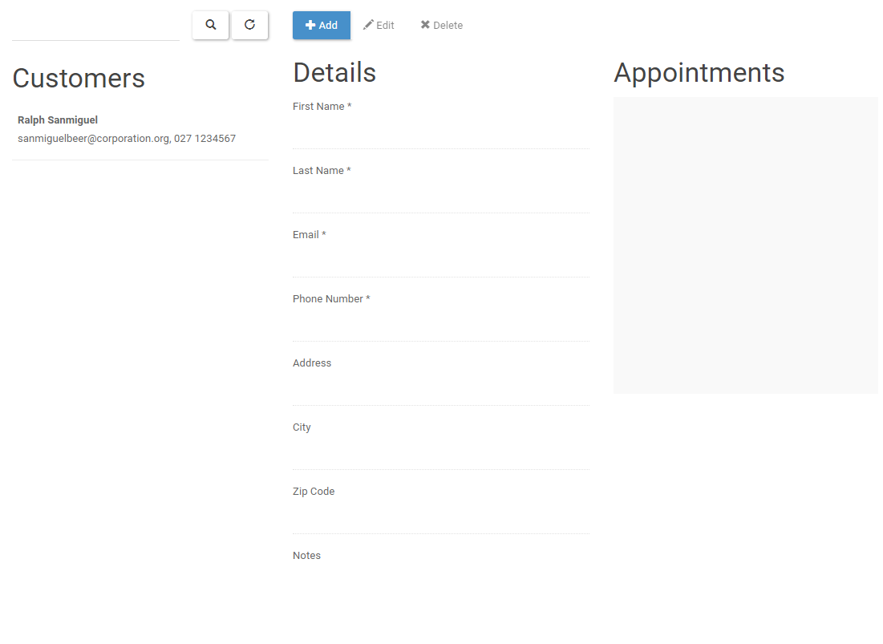

1. Then click on  button.
2. Then, please fill the required as you prefer;

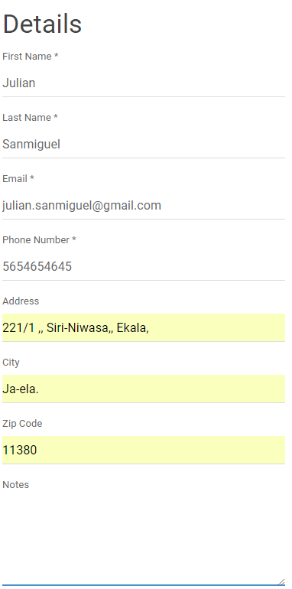

1. Then click button to save you work.
2. Then you will have your entered data right side.

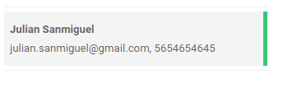

# How to check whether your new customer details properly saved on the database?

Answer: -

Please follow the instructions to check whether your customer information saved properly into the database.

1. Please follow the URL address to gain access into phpMyAdmin.

<http://3.95.28.149/phpmyadmin/>

1. Then you will be able to access into phpMyAdmin homepage as follows;

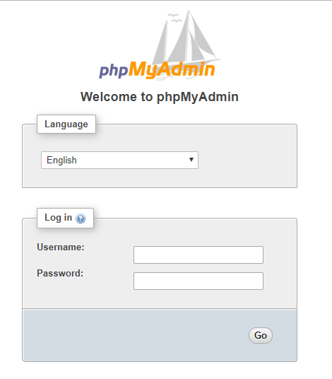

1. Then enter MariaDB database Username and Password to enter your database.
2. Then you will be able to gain access to following homepage.

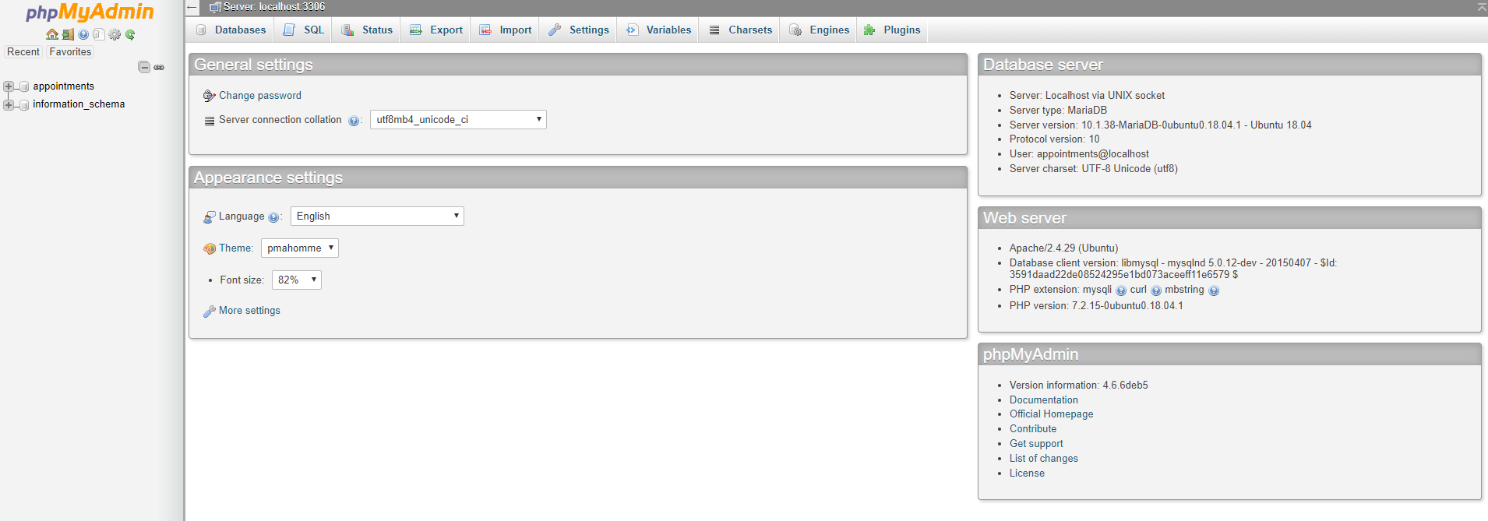

1. Then click on “appointments.”

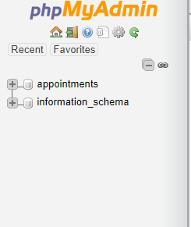

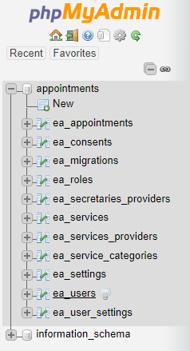

1. And you can check whether your data has been saved or not;

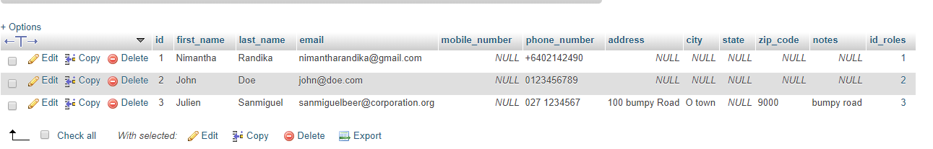

# How to add new service on back end section?

Answer: -

Please follow the below steps to add a new service and save it in the database.

1. Please select the customers section on top navigation bar menu on back-end homepage.



1. Then you will be able to enter following interface;

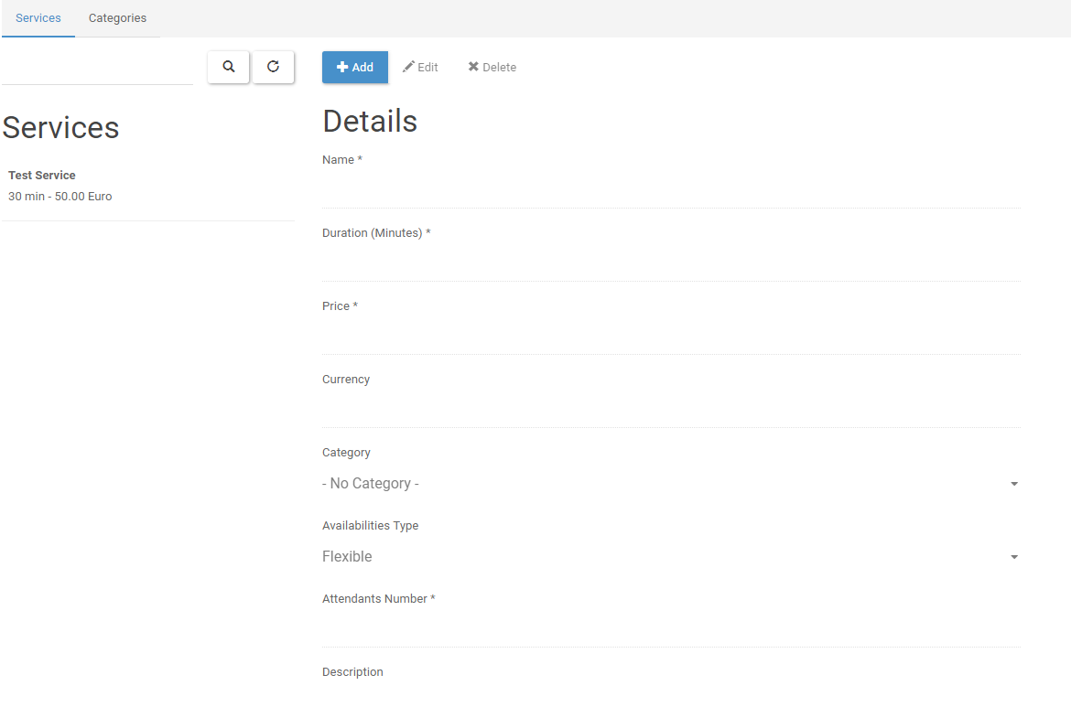

1. Then click on  button to procced further.
2. Then please fill the form as follows;

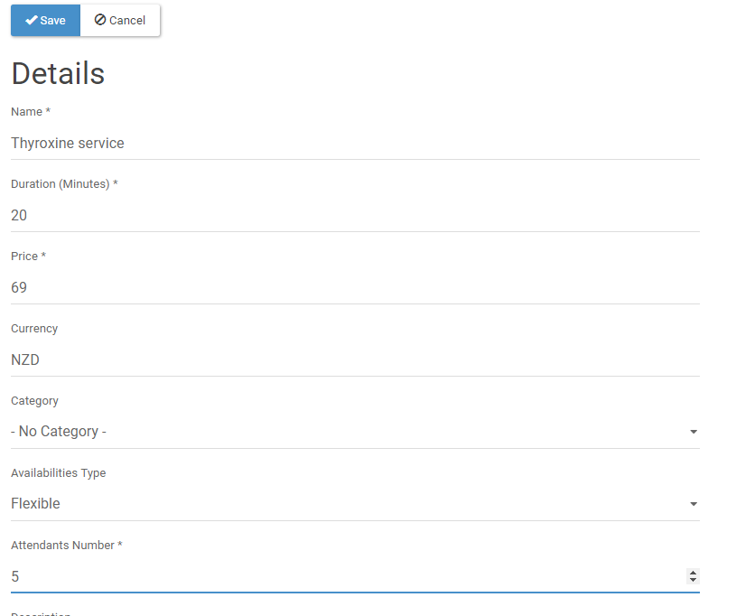

1. Then click  button.
2. Then you can see your entered data saved right side to you.

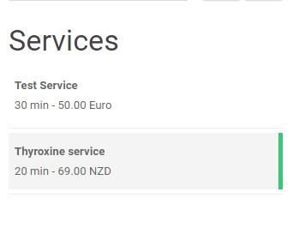

# How to edit customer details on back-end?

Answer: -

Please follow the below steps to edit customer details and save it in the database.

1. Please select the Customers section on top navigation bar menu on back-end homepage.



1. Then you will be able to enter following interface;

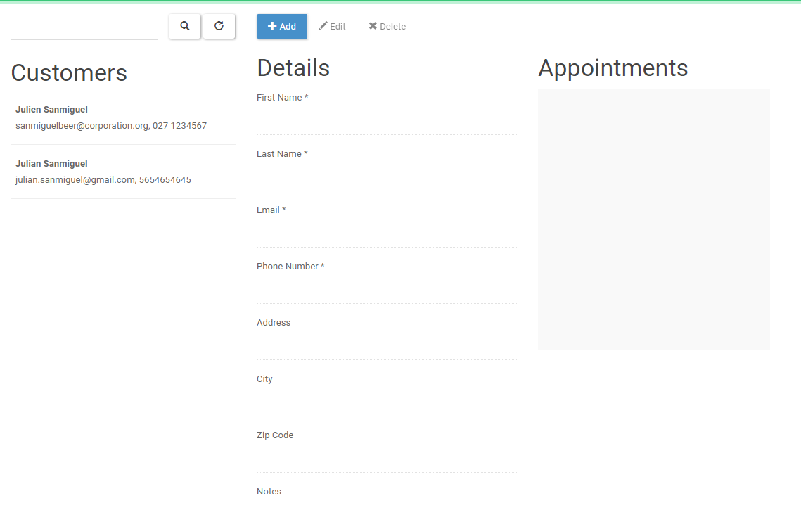

1. Now please select the customer you want edit.

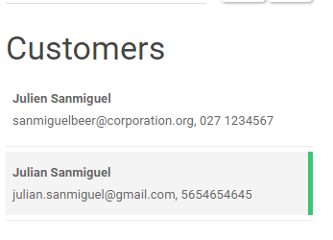

1. Now select the button.
2. Now edit the form as you prefer.

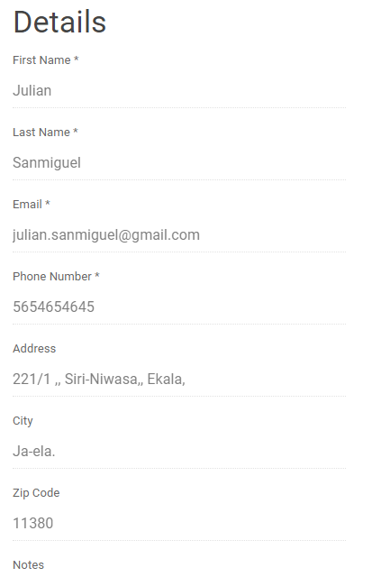

1. Now, select the  button to save your work.

# How to edit services details on back-end?

Answer: -

Please follow the below steps to edit services and save it in the database.

1. Please select the Services section on top navigation bar menu on back-end homepage.



1. Then you will be able to enter following interface;

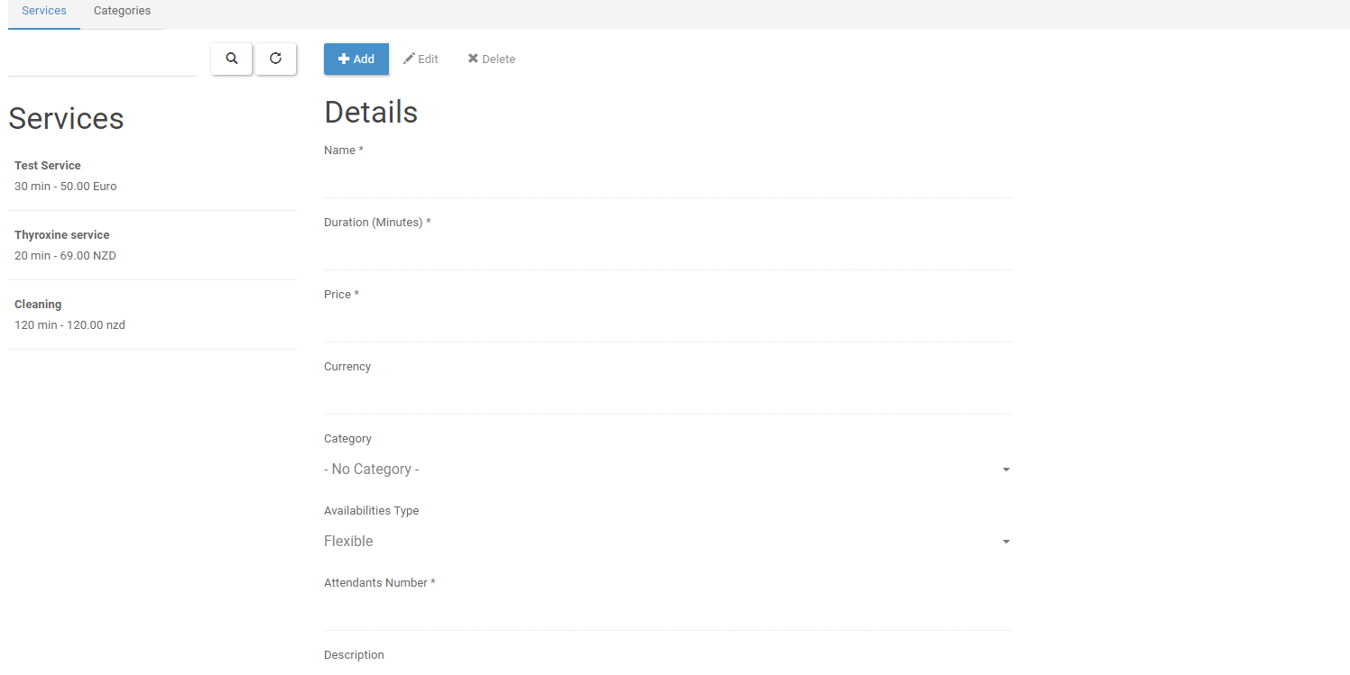

1. Now please select the service you want edit.

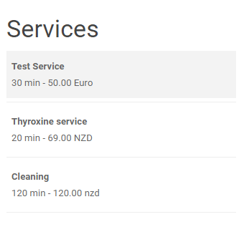

1. Now select the button.
2. Now edit the form as you prefer.

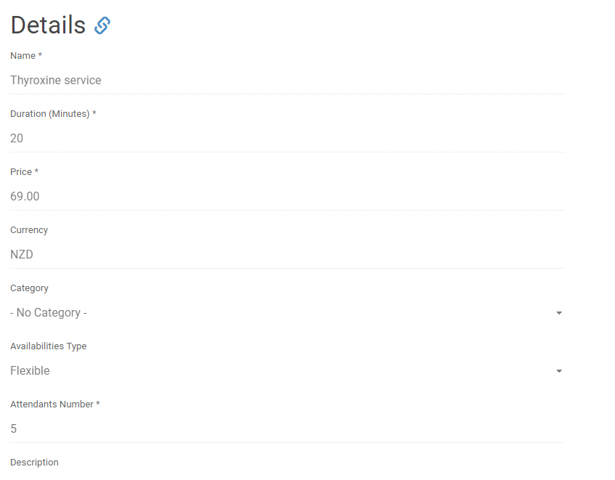

1. Now, select the  button to save your work.

How to delete services details on back-end?

Answer: -

Please follow the below steps to delete services and save it in the database.

1. Please select the Services section on top navigation bar menu on back-end homepage.



1. Then you will be able to enter following interface;



1. Now please select the service you want edit.



1. Now select the button.
2. Then it will pop out a confirmation message.

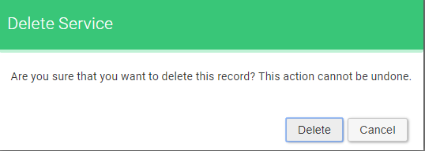

1. Then select button.

# How to delete services details on back-end?

Answer: -

Please follow the below steps to delete services and save it in the database.

1. Please select the Services section on top navigation bar menu on back-end homepage.



1. Then you will be able to enter following interface;



1. Now please select the service you want edit.



1. Now select the button.
2. Then it will pop out a confirmation message.



1. Then select button.

# How to delete customer details on back-end?

Answer: -

Please follow the below steps to delete customers and save it in the database.

1. Please select the Customers section on top navigation bar menu on back-end homepage.



1. Then you will be able to enter following interface;

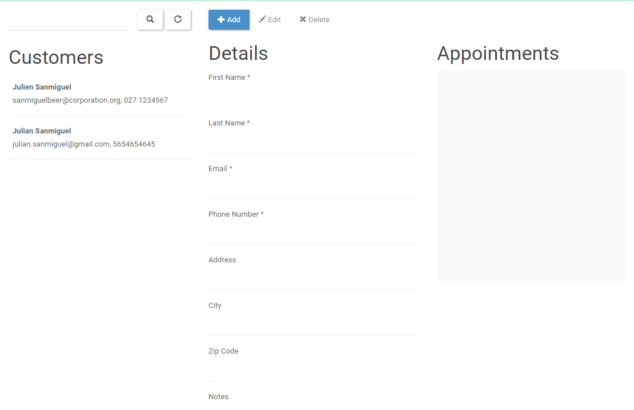

1. Now please select the customer you want delete.

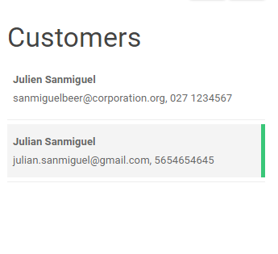

1. Now select the button.
2. Then it will pop out a confirmation message.



1. Then select button.

# How to add providers for each service on back end section?

Answer: -

Please follow the below steps to add a new service provider and save it in the database.

1. Please select the Users section on top navigation bar menu on back-end homepage.



1. Then you will be able to enter following interface;

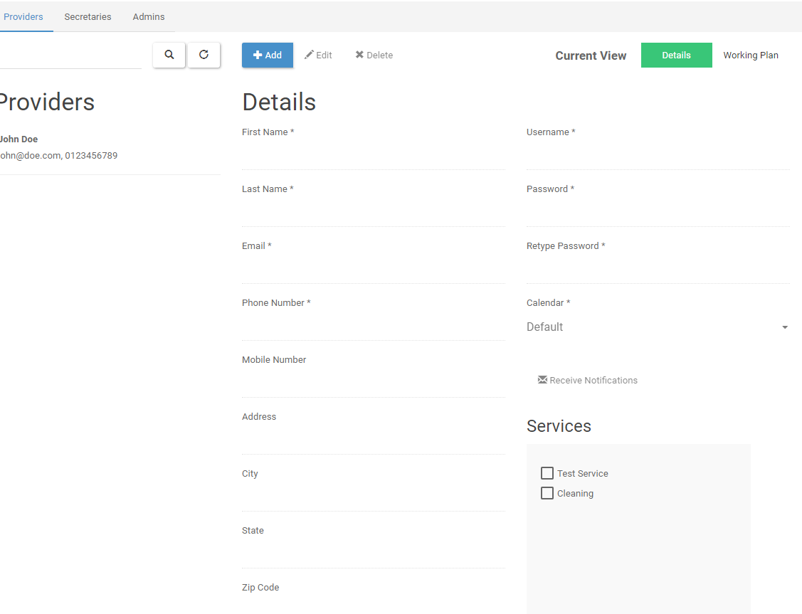

1. Then click on  button to procced further.
2. Then please fill the form as follows;

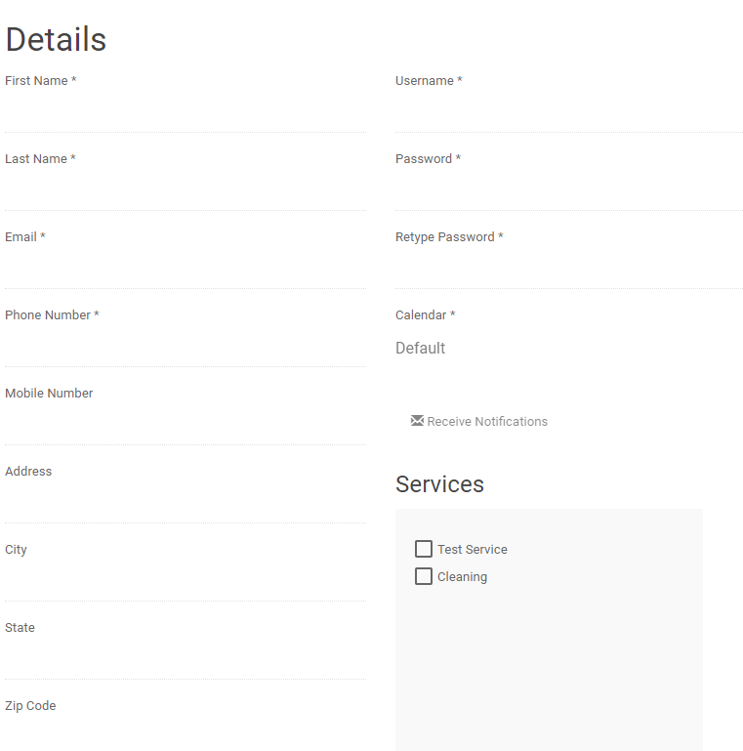

1. Then click  button.
2. Then you can see your entered data saved right side to you.

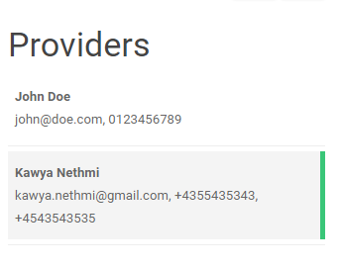

# How to edit service providers details on back-end?

Answer: -

Please follow the below steps to edit service providers details and save it in the database.

1. Please select the Users section on top navigation bar menu on back-end homepage.



1. Then you will be able to enter following interface;



1. Now please select the service you want edit.

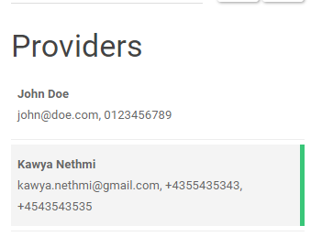

1. Now select the button.
2. Now edit the form as you prefer.

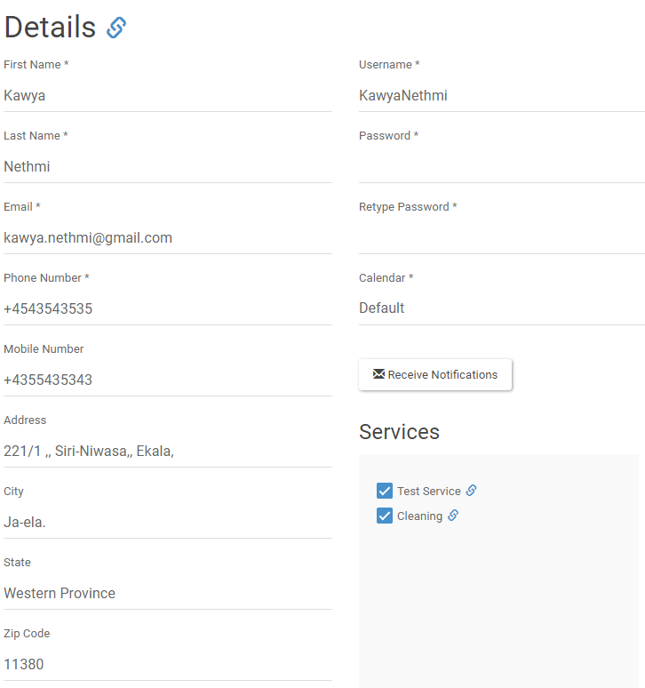

1. Now, select the  button to save your work.

# How to delete service providers details on back-end?

Answer: -

Please follow the below steps to delete service providers and save it in the database.

1. Please select the Customers section on top navigation bar menu on back-end homepage.



1. Then you will be able to enter following interface;



1. Now please select the service provider you want delete.

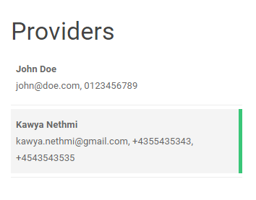

1. Now select the button.
2. Then it will pop out a confirmation message.



1. Then select button.